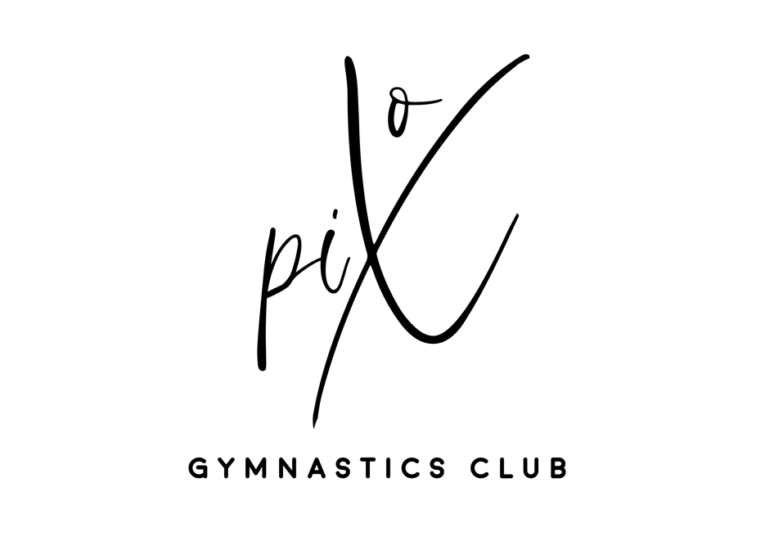

**Complaints and Grievance Procedure**

Pix Gymnastics Club is committed to providing a safe, stimulating and accessible service to all of its members. We aim to provide a high quality service at all times and for everyone, however we accept that sometimes things do not go to plan.

This policy is designed to help resolve complaints and grievances as quickly and fairly as possible. All complaints/grievances will be dealt with sensitively and confidentially at all times.

If your matter is related to safeguarding, you need to contact the welfare office by emailing [Welfare.pixgymnastics@gmail.com](mailto:Welfare.pixgymnastics@gmail.com)

This policy applies to all club members, their parents / guardians and all staff members employed by Pix Gymnastics Club

**PROCEDURE Stage 1**

If you have a complaint or grievance, you should in the first instance speak to the individual concerned. Alternatively, you may request a feedback/complaints form and on completion, hand to one of our staff on Reception entrance.

The complaint/grievance should be raised as soon as possible. You will be advised of the next step that will be taken to resolve your complaint/grievance and you will receive a final response within ten working days.

In the event the matter is not resolved, Stage 2 of this procedure will come into operation.

**Stage 2**

If you are not satisfied with the outcome at Stage 1, you may submit a written statement of the grievance to the Club Manager / Chair of the Pix Gymnastics Club Committee. You should do this within ten working days of receiving the final response at Stage 1. Please include all relevant names, dates, evidence and other important information related to the complaint/grievance. The Club Manager / Chair will acknowledge receipt of your complaint / grievance and fully investigate the matter within ten working days. They will keep you up to date with any developments, will advise you of any delays and will inform you of their decision in writing.

If you are still not satisfied with the outcome, you may contact British Gymnastics.

**Contacts:**

Club Manager: pixgymnastics@gmail.com

Pix Gymnastics Club Committee Chair: chair.pixgymnastics@gmail.com  
Pix Gymnastics Welfare officer: [Welfare.pixgymnastics@gmail.com](mailto:Welfare.pixgymnastics@gmail.com)

British Gymnastics: 0345 1297129 or www.british-gymnastics.org